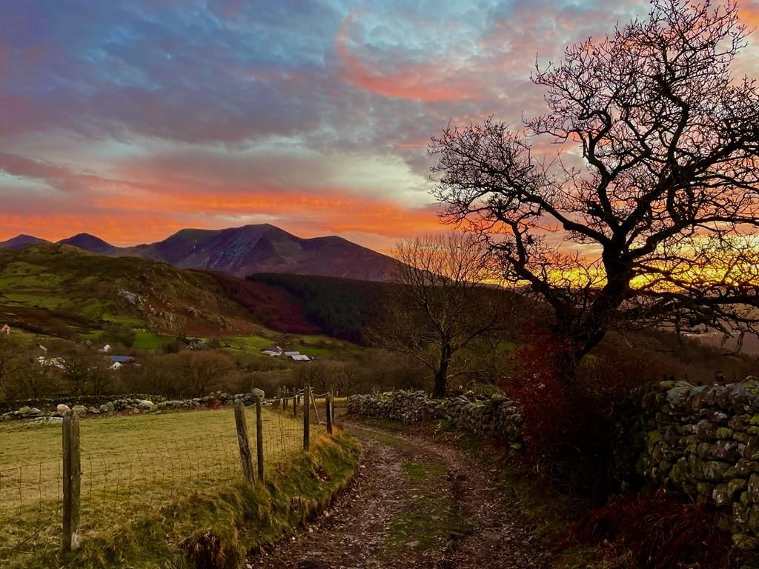

Adventure seekers /
Ceiswyr antur
“Then we have our lake, Llyn Tegid, The lake of beauty” George Burrows
WILD WALES: The PEOPLE LANGUAGE & SCENERY

by: George Borrow Victorian Adventurer 1862

“Then we have our lake, Llyn Tegid, the lake of beauty”.
The lake has certainly not its name, which signifies the Lake of Beauty, for nothing. It is a beautiful sheet of water, and beautifully situated. It is an oblong about six miles in length. On all sides, except to the north, it is bounded by hills. Those at the southern end are very lofty: the tallest of which is Arran.
On enquiring about the nature of the road he told me the first part of it was tolerably good, lying on the eastern side of the lake, but that the greater part of it was very rough, over the hills and mountains belonging to the great chain of Arran, which constituted upon the whole the wildest part of all Wales.

And so the cycling adventure that is The Wild Wales Challenge was named. Each August bank holiday for the last 39 years riders have followed routes around the wildest part of all Wales sometimes in brilliant sunshine and sometime not! It has sought to follow the lesser-known highways and byways of this stunning area of North Wales.
2024 will see the 40th year of the most spectacular event in the cycling calendar and as such we’d like to invite as many riders as we can to celebrate this great event as we head southeast from Bala.

What can I expect?
It is often mooted that the best views come after the toughest climbs. Ask any veteran of this great event and there are many riders who have ridden multiple times and they will all tell you the views are stunning, which by inference suggests lots of climbs and some tough ones too. It is after all a challenge, but not a race so there is enough time to enjoy the views and complete the route. There are two routes, the longest also has the greater amount of climbing. It is generally undertaken by cycling club members and cyclists who routinely ride longer distances. The shorter route is no push over as it shares a significant section of the route with the longer version and upon completion of either route comes with a commemorative Welsh slate plaque.

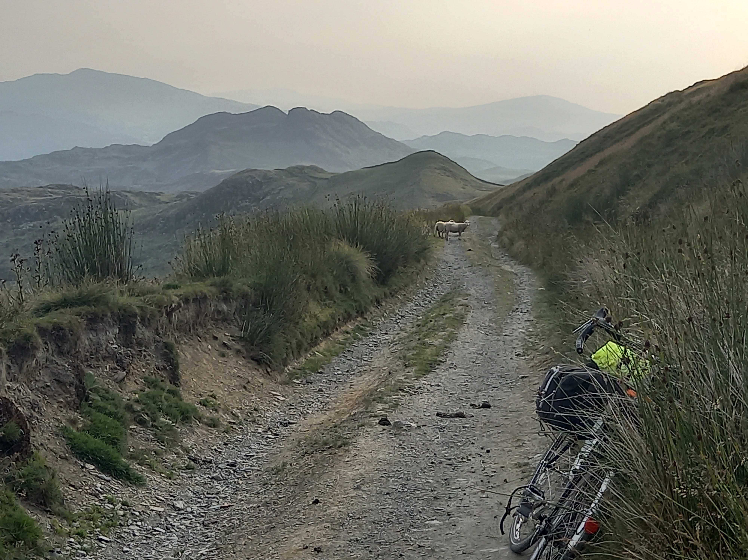
What Bike will I need?
To paraphrase Joseph; any bike will do! Perhaps, not the shopper bike or even the 1970’s chopper lying rusting in the shed. But bikes do come in many guises: gravel; mountain; road; or sport to name a few. Some machines will make the experience better some not, but it is not the type of bicycle that is important, rather the person who rides it. Yes-some bicycles may enhance the ride, but it is the rider that enjoys the experience and camaraderie of this unique challenge.

Whatever the bike, both routes demand a roadworthy machine with good wheels, brakes and gearing. The roads remain open to all traffic for the event so adherence to the rules of the roads is mandatory. What isn’t mandatory is the choice of clothing, wear Lycra if you wish, don’t if you don’t. Comfortable clothing works for a long day and make sure you have waterproofs should the day prove less than sunny!!

There is a charge to ride the event, but you do get fed at several locations where there are also toilets etc. The charge is to cover legitimate costs associated with the event and any surplus helps towards next years challenge or cycling events. There is also a small campsite for those that wish to pitch up at the start, again a small charge to cover the hire of the site. Over the years excess monies from the event have supported many cycling causes such as the Cyclist’s Defence fund, Merseyside cycling campaign and Eastham Community cycling to name a few. Other good causes not cycling related have been Hand in Hand for Syria, Asylum link Merseyside and MACCA a charity for hurricane victims in the Caribbean. This year we will make a contribution to Claire House Charity assuming of course we get sufficient riders to create excess.

Being adventurous is a primeval urge, to wonder what’s over the next hill or beyond the horizon are feelings we all know, George Borrows knew, it too. Adventure combines so beautifully with cycling. To move through the world, listening, seeing and feeling the environment yet doing so very little damage to It, should inspire us all. So hopefully we’ll see you in Bala for an adventurous and challenging cycling day out to remember.

How do I sign on.
Simply go to Merseyside CTC website and follow links to the Wild Wales Challenge and book the event but be quick there are a limited number of places.

